Gamma News – Unfolding Here 1
March 2024

March Meeting: Saturday March 16, 2024 – 11:30-1:30
Donna Harper’s home 760 Star Apple Lane (760) 224-5782 Gate code: #8457
Presentation of Kids Activities in Vegas, and enjoy an Irish lunch.
Donna will supply basket
Please let Donna know that you are coming so she knows how many to prepare for.
- The new State Convention Planning Committee would like us to discuss some questions at the March meeting. Points are listed at the end of this newsletter.
- Also, review the Apple Award Application [included towards the end of this newsletter]

April 12-13 State Convention hosted by Omicron & Xi in Winnemucca Registration and Information available
April Meeting: Saturday April 20, 2024 at 10:30
Field Trip to the Desert National Wildlife Refuge
We will meet at the Visitor’s Center at 10:30 [https://www.fws.gov/refuge/desert].
We will be stopping for lunch at the Las Vegas Paiute Golf Resort [https://lvpaiutegolf.com/bar-grill.html] on our way back.
Basket Raffle - $5 buy in – Karen will supply the basket

Founder’s Day – May 4
See Flyer for details
Queen of Hearts
Guests are Welcome!
DKG Founders, 5/4/24 @11 am
Afternoon Tea Booking, $45/person
(tax & gratuity included)
Quantity: 1pl, Traditional or Vegan Menu
Total: $45

You will need to register online or by phone directly with them. Confirmation will be sent once payment is complete. DKG is our code.
*If paying separately, please have your Guests reference the name & date of your party.

Alpha Chi Nevada Apple Award
Application Form

Name:_____Lisa Lee______Phone# 702-799-7103 ext. 4025
Position: Library/STEM Email: leelg@nv.ccsd.net
School: Cahlan Elementary School
Grade(s) and Number of Students involved: Kindergarten -5th grade, 450 students
Title of Project: Hydroponics
Briefly describe project: Students will learn that plants can grow with hydroponics, and that like growing traditionally in soil, the plants require the same elements, like water, air, light and nutrients. Students will grow their plants in a Kratky system. The project requires plastic containers, various types of seeds, rockwool plugs for seeds, and seed net pots to hold the seeds over the water. Through this project, the students will be able to grow plants in water, and also learn about the care and time it takes to grow plants.
Monetary amount requested: $250

Things the new State Convention Planning Committee would like us to discuss – so be thinking about them for the March meeting.
• What do your members want from DKG?
• How do you decide to attend or not attend a State Convention?
• Why do you go to the State Convention?
• What do we, as planners, need to do to encourage our members to attend the State Convention?
• Do you feel the State Convention should focus more on state business, socializing, programs of interest to the individual and chapters or programs focused on the concerns of International?
• Should the Convention Banquet maintain the tradition of formal attire and the Parade of Presidents?
• How do you see the future of the State Convention? Will it be a face-to-face or be by ZOOM?
• How can the State increase and improve communication with the Chapters and individual members?
• Should Leadership training be incorporated into the Convention schedule?

Reminder, this month’s trivial pursuit is about ROSES

What does the color of the rose say? Match the color with the meaning.

Your choices… Coral, Lavender, Orange, Pink, Red, White, Yellow

Love, passion, courage, and respect
Purity, innocence, and virtue
Admiration, joy, gratitude, and appreciation
Friendship and joy
Enthusiasm and desire
Enchantment and love at first sight
Desire and enthusiasm
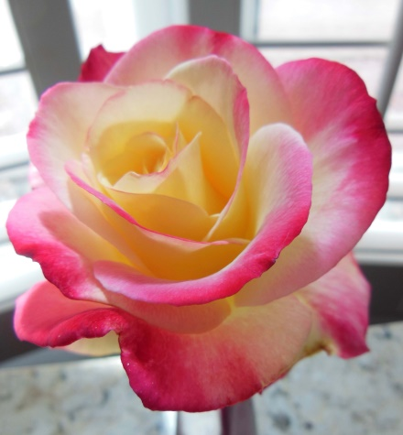
Coral, Orange, Pink, White, Yellow…
This rose is SO confusing…

